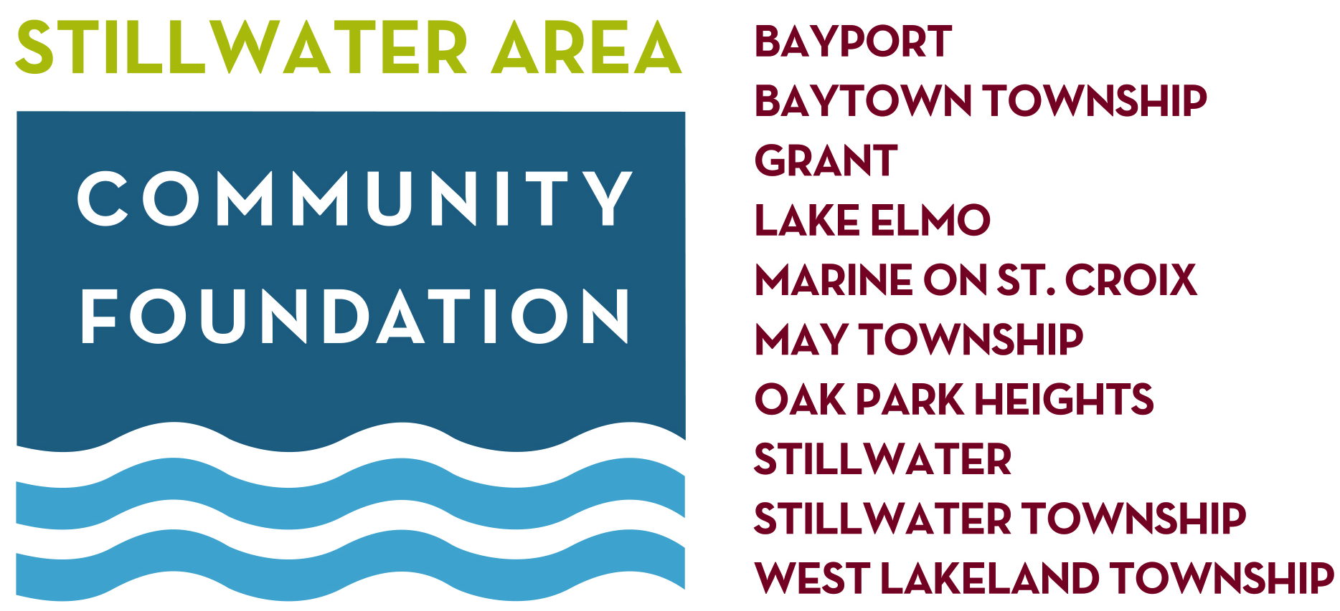

Contact:
Name, Title (title can go on line below)
phone or email (reporters are on deadline–be reachable)

HEADLINE BOLD ALL CAPS LEFT JUSTIFY – KEEP TO ONE LINE IF POSSIBLE

[STILLWATER, Month XX, 2019] – Main message of the press release. Why are you sending it? The 2-3 sentence reason this is of interest to the media outlet’s readers.

Description and explanation. The background, further detail, the impact, the support for the proposition as stated in headline and first paragraph. Facts, dollar amounts, hot links to other supporting studies, content, online forms, etc. Remember to make sure links are working/ready to go before sending.

Sub Heads Can Be Used If They Aid Understanding/Dissemination of More Complex Topics
Example: an event, including date, place, time, speaker, etc. These may be most clear and readable as a bullet point list within the press release. List any partnering organizations or sponsors.

If it is a grant request announcement, include those eligible, needs being addressed, impact for community and opening and closing date for applications.

If gift impact press release, include dollar amounts, intended uses, longevity of gift, donor’s relationship to the community (if donor is agreeable to press) and notable reasons for their philanthropy.

Quote(s) from influential/credible individual if quote enhances/lends further credibility to the message. Example: (note: shorter quotes can remain in body of a paragraph and do not need to be tab blocked as this longer quote is).
Dr. Kris Tjornehoj, chair of SCVF’s music education grant panel, noted,
“Since 2003, St. Croix Valley Foundation has offered a competitive grant program for music education. During that period 184 grants have been awarded totaling $445,000. Grants have provided dollars for instruments, sheet music, new compositions, clinicians, technology and joint school concerts among others. Some requests are innovative, and others replace aging instruments that can no longer be repaired. We want music teachers to request money for things that will strengthen or improve their programs. Receiving a SCVF music education grant recognizes the commitment of that teacher and school to improve their music program. We have been told that grants help inspire both teachers and students to achieve more.”

(Bottom Blurb – italics -- your regular statement of identity, this should be at the bottom of all press releases – it’s a quick way for a reporter to be familiar with your organization without having to look you up online. Bottom Blurbs should include a link to your website.)

Stillwater Area Community Foundation
Established in 2010, the Stillwater Area Community Foundation works with a 100% volunteer board to advance the quality of life in Bayport, Bayport Township, Grant, Lake Elmo, Marine on St. Croix, May Township, Oak Park Heights, Stillwater, Stillwater Township and West Lakeland Township. The foundation is a community trust – ensuring gifts donated today will be professionally managed and wisely utilized to enhance the future well-being of its service area communities.
www.stillwaterareafoundation.org

St. Croix Valley Foundation provides support to ten, volunteer-driven, affiliated community foundations. That support includes 501(c)3 credentials, fiduciary expertise, board and committee guidance, office and staff support and – most importantly – a shared understanding of and love for the St. Croix Valley.
www.scvfoundation.org

#
(this mark indicates end of the press release – so reporter knows there is not another page)
__________________________________________________________

FURTHER TIPS:
Finalize press release as an attached PDF AND include the text content in body of the email. Some reporters will not open unknown PDFs so having the content in body of email solves that.

Putting content in body of email is why fully Left Justified layouts will be a time saver. Text copied and pasted directly from your press release within the body of email should be left justified for ease of readability, especially on hand help devices.

If possible, address the reporter by name in body of email.
Hi John, I thought this information on education grants would be of interest to your readers. – Ellen

Submitted Photos. Attach as JPEGs of a 300 dpi quality. If the photo is not 300 dpi, it cannot be printed in a newspaper or magazine. Indicate a photo credit (who took it), or indicate “Photo Credit Not Necessary.” --In this case the paper will simply credit the photo as “Submitted Photo.” Don’t bother sending photos that are not quality layout and lighting.

Your press release and photos should make the reporter’s job as easy as possible – answer every question, supply credible quotes, supply links for the reporter’s reference. The best press release will get printed nearly the way you send it because you’ve written it with the newspaper editor and his/her readers in mind.

Good luck sharing your message with your community!
Please contact us at St. Croix Valley Foundation if we can help in any way.
-Ellen

